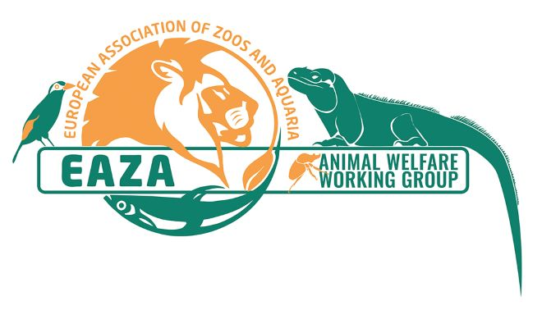
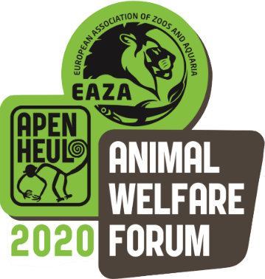
EAZA Animal Welfare Forum
‘Bridging the Gap‘
24-26 March 2020
Apenheul Primate Park,
The Netherlands

Abstract Submission Form

The topic of your abstract should support the forum theme - ‘Bridging the Gap’ - bringing together animal welfare research and application, to improve evidence-based animal welfare best practice.

We are opening our second round of abstract submission with a focus in the areas of research surrounding the Five Domains of Health, Behaviour, Environment, Nutrition and Affective states and how research in these areas can be linked directly back to animal welfare and implementation within our zoos and aquariums. Submissions are welcomed from both practitioners and researchers in all fields of animal science.

- Submissions are welcomed from both practitioners and researchers.
- Abstracts should be no more than 300 words and written in English. Indicate if your submission is for an oral presentation (20 minutes), poster or workshop (1 hour).
- All delegates, including speakers, must register for the conference.

Please submit your abstracts to EAZA Animal Welfare Coordinator, Melissa Broadway
melissa.broadway@eaza.net, before 30 October 2019,
with ‘AWF20 - [Poster/workshop/presentation] - Abstract - [Name]’ in the subject line.

Please tick which type of presentation you would like give:

Poster presentation Oral presentation Workshop

Author(s):
Presenting Author:
Institution:
Email:
Abstract title:
Abstract:
(maximum 300 words)
With regards to submissions of abstracts for oral and workshop presentations, has this presentation been given at any other forums/conferences etc? If so, please give details:

Please submit your abstracts to the EAZA Animal Welfare Coordinator, Melissa Broadway, melissa.broadway@eaza.net, before 30 October 2019, with
‘AWF20 [Poster/workshop/presentation] Abstract [Name]’ in the subject line.

