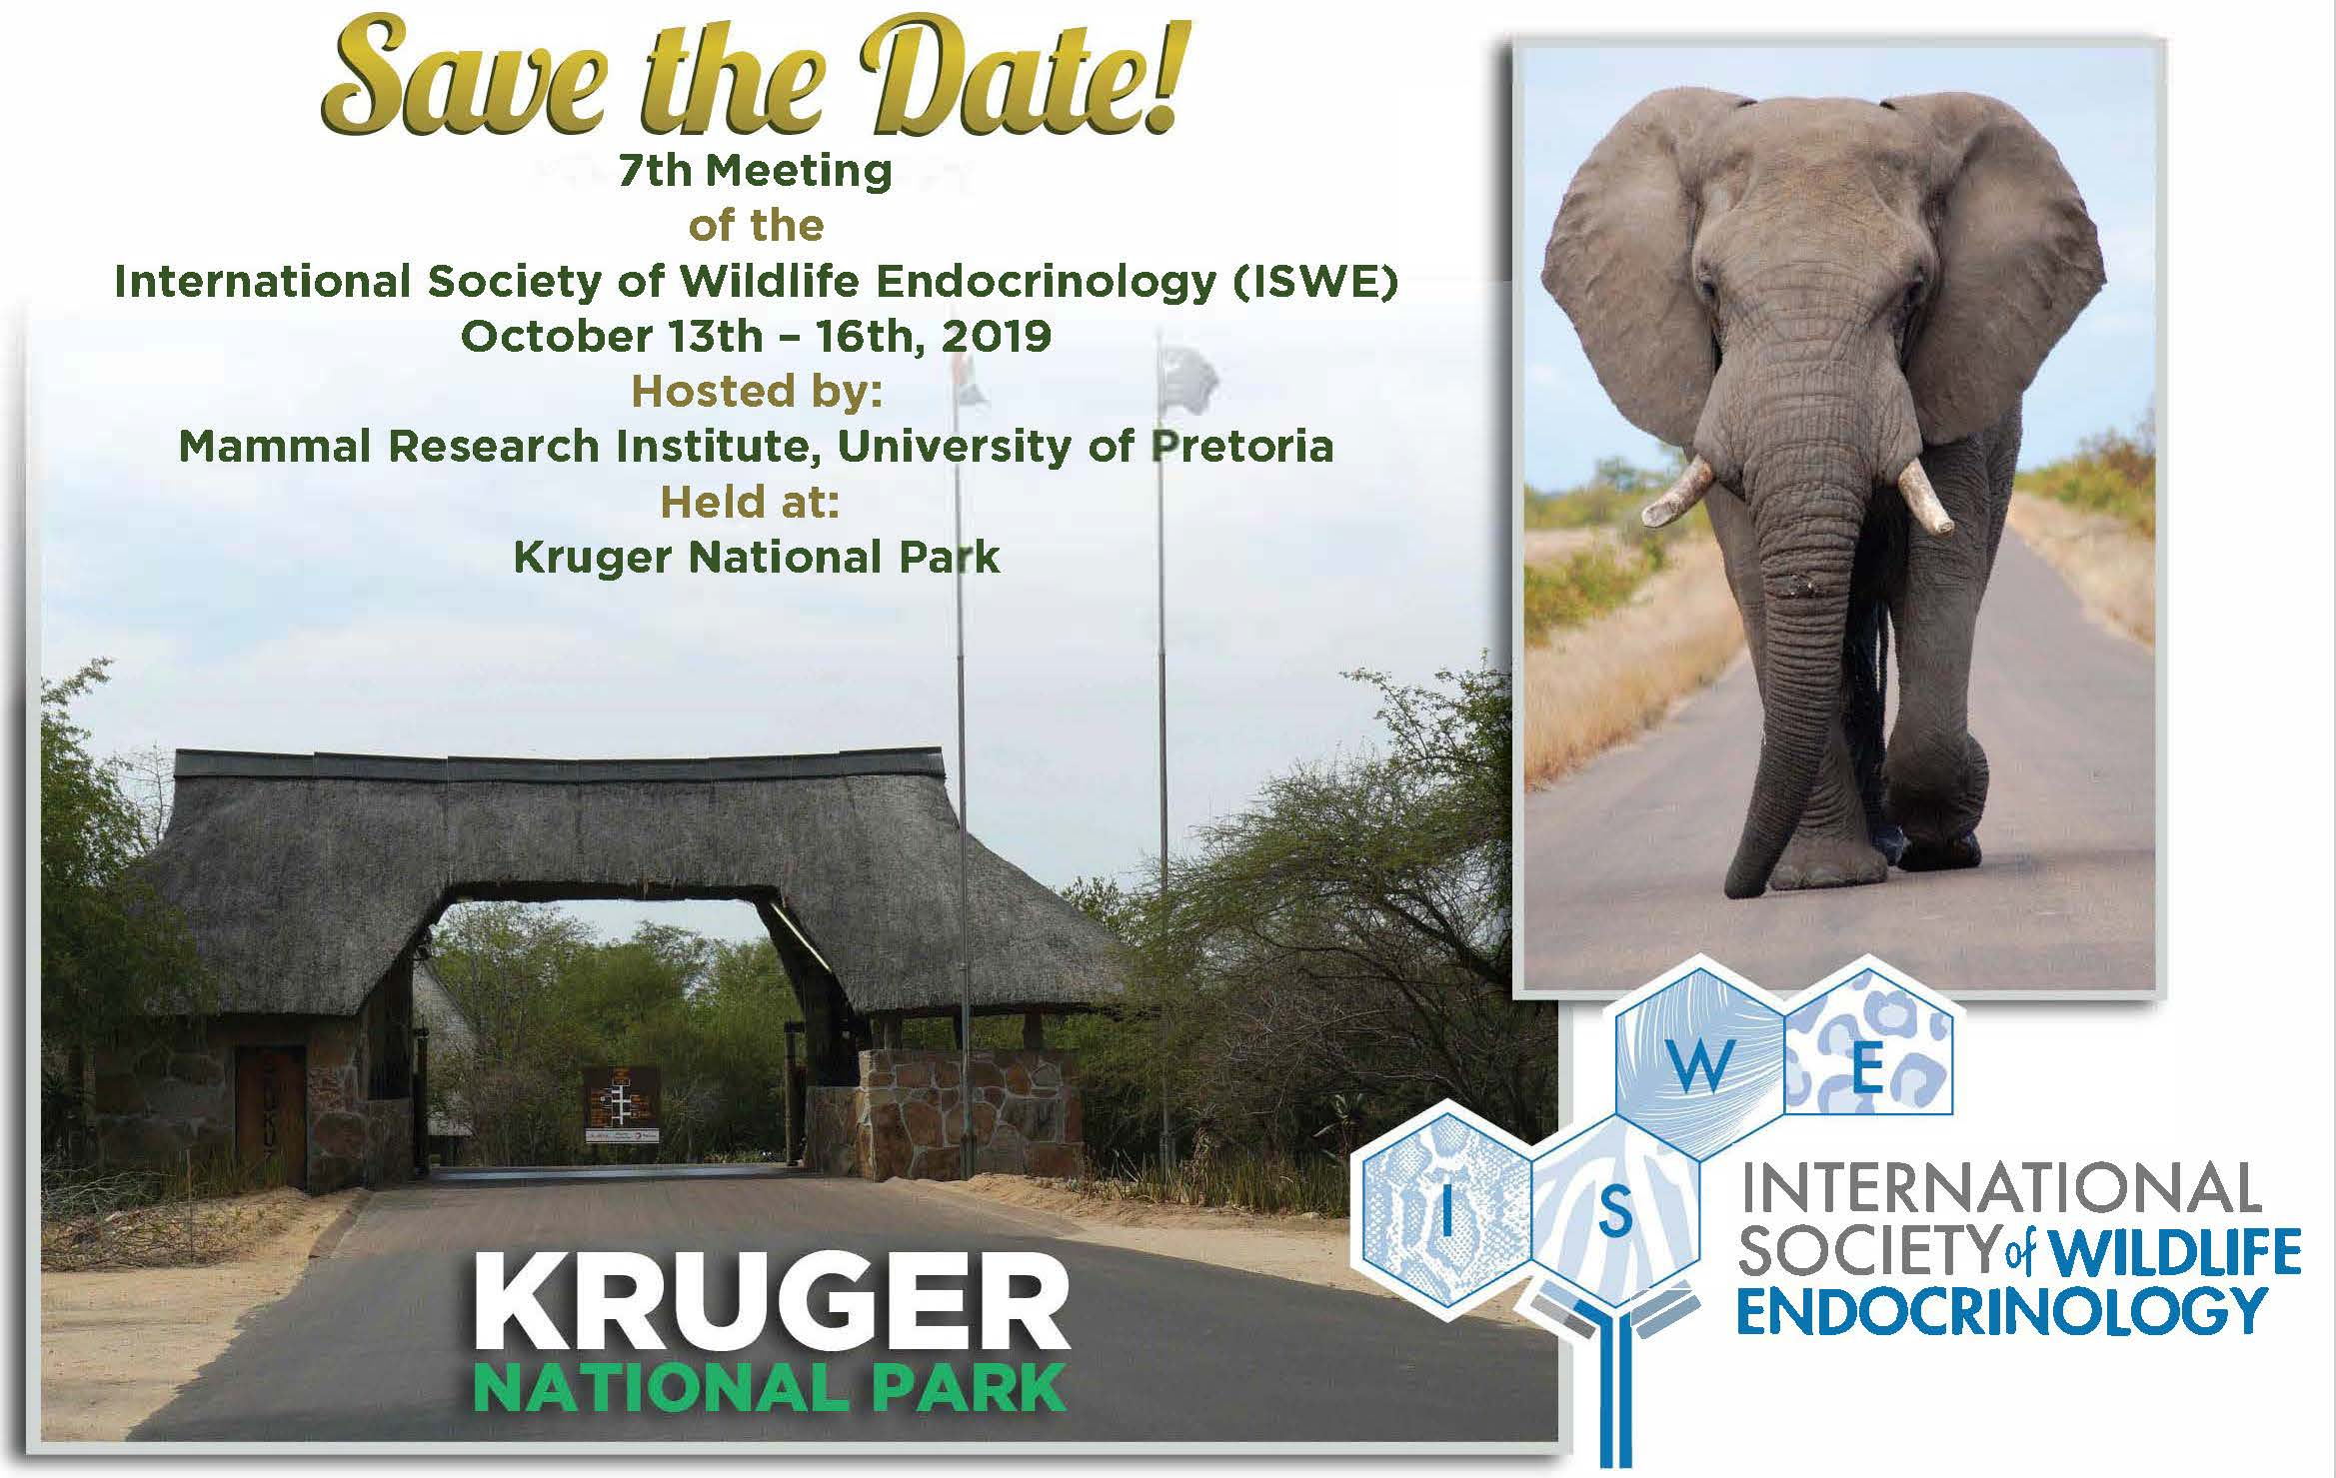

The International Society of Wildlife Endocrinology (ISWE) is currently accepting abstract submissions for the 7th ISWE Meeting. ISWE welcomes abstracts reporting new basic, applied, or methodological-related findings concerning wildlife endocrinology, with an emphasis on non-invasive and minimally invasive sampling technologies used to address questions regarding adrenal function, reproductive physiology, animal health, ecology and evolution. Topics include: methodologies, reproduction, stress, animal health and welfare, wildlife conservation, and miscellaneous.
Travel scholarships are available for graduate and postdoctoral students. Abstracts are due by March 15, 2019. For more information and to submit an abstract, visit the ISWE website at https://www.iswe-endo.org/conference/

