EAZA Animal Welfare Forum
‘Bridging the Gap‘
24-26 March 2020
Apenheul Primate Park,
The Netherlands

Abstract Submission Form
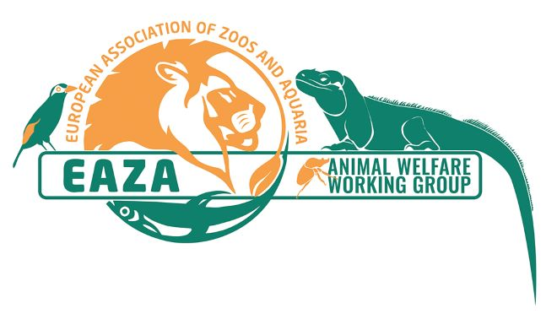

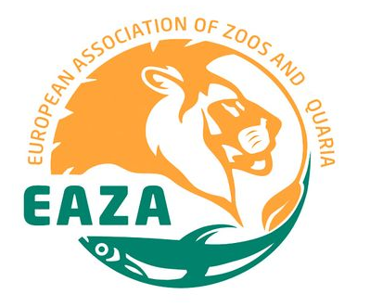

Please tick which type of presentation you would like give:

Poster presentation Oral presentation Workshop

Author(s):
Presenting Author:
Institution:
Email:
Abstract title:
Abstract:
(maximum 300 words)
With regards to submissions of abstracts for oral and workshop presentations, has this presentation been given at any other forums/conferences etc? If so, please give details:
Please submit your abstracts to the EAZA Animal Welfare Coordinator, Sally Binding, sally.binding@eaza.net, before 16 June 2019, with
‘AWF20 [Poster/workshop/presentation] Abstract [Name]’ in the subject line.

